**4. Photometric measurements can be used for determining distance and comparing objects**

* Before we go on, I just thought that it would be useful to define photometry – photometry is the measurement of the brightness of astronomical objects (including stars, nebulae, asteroids and galaxies).

***Define absolute and apparent magnitude***

* Apparent magnitude (symbol = m) is defined as the brightness of a star, using the magnitude scale, as viewed from Earth. Thus, it is affected by: the star’s temperature; the star’s surface area; the distance of the star from the Earth; and external factors (such as interstellar dust, which can make stars appear dimmer).
* Absolute magnitude (symbol = M) is defined as the brightness of a star, using the magnitude scale, as viewed from a standard distance of 10 parsecs away. Because the distance of separation is fixed, it is no longer an influence and so absolute magnitude is a measure of the star’s ‘intrinsic’ brightness (accounting for external factors, such as interstellar dust), thus proving to be a useful means of making direct comparisons between stars.
* Note: Therefore, if two stars have the same apparent magnitude but are different distances away from Earth, the closer star will have an absolute magnitude smaller than that of the star further away.
* The “scale for brightness” was invented by Greek philosopher Hipparchus, who observed the night sky with the naked eye. His scale ranged from ‘magnitude 1’ to ‘magnitude 6’, but it was the brightest star visible that was assigned ‘magnitude 1’ and the dimmest star was assigned ‘magnitude 6’. Therefore, he used a ‘reverse’ scale, with lower numbers indicating brighter stars.
* We still use this scale today, but it is has extended beyond the original 6 values. This is because stars have been found that are brighter than magnitude 1 (Sirius, the brightest star in the night sky, has a magnitude of −1.4) or dimmer than magnitude 6 (large telescopes can observe stars as faint as magnitude 25)
* Note: Measurements of absolute/apparent magnitude can be made photographically or photoelectrically.
* Note: Both apparent and absolute magnitude have *no units*.
* *Example Q* 🡺
  + **Question** 🡪 Use this table to answer the following questions:

1. Which star had the greatest luminosity?
2. What star is the dimmest as seen from Earth?

|  |  |  |
| --- | --- | --- |
| STAR | APPARENT MAGNITUDE | ABSOLUTE MAGNITUDE |
| Rigel | +0.14 | – 7.1 |
| Aldebaran | +0.86 | – 0.7 |
| Canopus | – 0.72 | – 3.1 |

* **Solution to a)** 🡪 Rigel, because it has the most negative absolute magnitude.
* **Solution to b)** 🡪 Aldebaran, because it has the most positive apparent magnitude.

***Explain how the concept of magnitude can be used to determine the distance to a celestial object***

* If a star’s absolute magnitude can be determined and the star’s apparent magnitude is measured, then using what is known as the ‘distance modulus formula’ can allow us determine the distance to the star.
* The equation is $M=m-5\log{(\frac{d}{10})}$, where:
  + M is the absolute magnitude of the star
  + M is the apparent magnitude of the star
  + d is the distance from Earth to the star, in parsecs (pc)
  + log refers to the logarithmic function to the *base 10*
* Alternately, the equation can be re-written as $m-M=5\log{(\frac{d}{10})}$, and this gives rise to the equation being called the ‘distance modulus formula’, since the term $m-M$ is known as the “distance modulus”.

***Outline spectroscopic parallax***

* Spectroscopic parallax is a method of using the H–R diagram and the distance modulus formula to determine the approximate distance of a star. It involves the following steps:

1. using photometry to measure the apparent magnitude (m) of the star in question
2. using spectroscopy to determine the star’s spectral class, as well as its luminosity class, since one spectral class can cover more than one major grouping (e.g. a star of spectral type K5 can either be a main sequence star, a giant or a supergiant)
3. consulting the H-R diagram to determine the star’s approximate absolute magnitude (M)
4. with estimates of m and M obtained, using the distance modulus formula to calculate the approximate distance to the star

* A problem with spectroscopic parallax is that the value determined for the star’s absolute magnitude can carry a large percentage error and, therefore, so will the calculated distance as well. Consequently, the distance determined by this method is approximate only, and thus spectroscopic parallax is generally used to give a ‘ball-park figure’ when no other technique can.
* Note: The name ‘spectroscopic parallax’ is actually misleading, because there is no parallax measurement involved. Make sure not to get confused in regard to this.

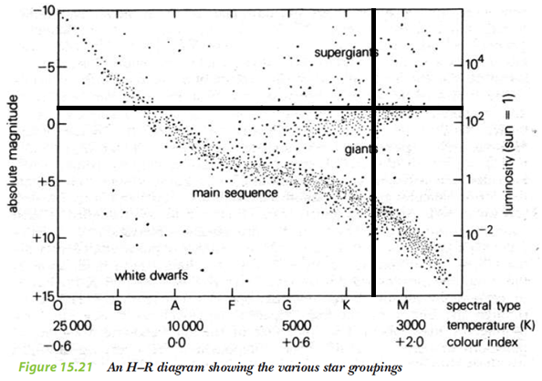

* *Example Q* 🡺
  + **Question** 🡪 Using the H-R diagram above, determine the approximate distance (to 2 decimal places) of the red star Aldebaran, if it has an apparent magnitude of +0.85, it belongs to spectral class K5 and it shines 425 times brighter than the Sun.
  + **Solution** 🡪
    - Using the H-R diagram, we go across the horizontal axis to midway between K and M, drawing a vertical line up from K5, as shown. Similarly, we find where 425 approximately is on the right-hand side vertical axis and draw a horizontal line across, also shown on the diagram.
    - Therefore, this seems to cross the left-hand side vertical axis between –5 and 0, but closer to 0. Thus, we’ll estimate the absolute magnitude of Aldebaran to be –1.
    - Consequently, for Aldebaran, $m=+0.85$ and $M=-1$ and $d= ??$
$∴M=m-5\log\left(\frac{d}{10}\right)$

$(-1)=(+0.85)-5\log{(\frac{d}{10})}$

$-1.85=-5\log{(\frac{d}{10})}$

$0.37=\log{(\frac{d}{10})}$

$∴\frac{d}{10}={10}^{0.37}$

$d={10}^{0.37}×10$

$d=23.44 parsec \left(to 2 d.p.\right)$

* *Note* – Two important things are to be noted:
  + Aldebaran’s actual distance from Earth is 20 parsecs, so we have arrived at a calculation with a 17.2 percentage error, hence showing the unreliability of spectroscopic parallax.
  + Sometimes, the question will tell you the star’s luminosity which enables you, by also using the star’s spectral class, to pinpoint a specific point on the H-R diagram. However, other questions might simply tell you the star is a main sequence star, a red giant or a white dwarf etc. and this can be used instead of luminosity, to help pinpoint a specific position.

***Explain how two-colour values (e.g. colour index, B-V) are obtained and why they are useful***

Contextual Introduction

* Originally, apparent magnitude values were assigned by naked eye comparison with well-known “reference stars”. However, a century ago, astronomers began taking photographs by telescope and measuring magnitudes by the degree of exposure on the photographic film. More recently, electronic detectors have been used by astronomers to measure the intensity of light.
* Each method gives a different magnitude value because:
  + the human eye is most sensitive to the yellow-green portion of the spectrum;
  + photographic film is usually more sensitive to blue-violet; and
  + electronic detectors respond equally to all wavelengths.
* These differences are then put to use in order to obtain what is known as a two-colour value.

How It Works

* Astronomers want to find out the ‘colour’ of a star, because it enables a determination of the star’s spectral class and temperature without the use of spectroscopy. However, as seen above, colour is a relative thing and, thus, astronomers need to define it and then have a way to quantitatively measure it.
* However, as we learnt in the ‘Cosmic Engine’, the intensity of energy emitted by the star varies with wavelength such that a hot star emits relatively more energy at blue wavelengths than at red whilst a cool star's emission peaks at red wavelengths.
* Therefore, what astronomers do is to measure the intensity of the star’s emission at specific wavelengths, and the intensity is referred to as colour magnitude (m). However, astronomers use filters to restrict the incoming light to a narrow waveband.

Looking at the “B-V Colour Index”

* Using a filter that only allows light in the blue part of the spectrum, astronomers can measure a star's ‘blue magnitude’ (mB or B) and this mimics the peak sensitivity of photographic film. Similarly, using a filter that mimics the eye's visual response which peaks in the yellow-green portion of the visible spectrum, astronomers also measure the star’s ‘visual magnitude’ (mV or V).
* Therefore, astronomers may define the colour of a star to be its “B-V colour index” (CI), which is simply a number equal to the difference between the ‘blue’ and ‘visual’ magnitudes of the star.
* This can be represented by either equation: $CI=m_{B}-m_{V}$ or $CI=B-V$
* In general, stars with a negative B-V colour index will appear more blue and stars with a positive B-V colour index will appear more yellow, orange or red. Let’s use an example to explain why:
  + For a blue star, it will appear very bright when viewed through a blue filter and quite dull when using a yellow filter. Thus, its ‘blue magnitude’ will be numerically small and its ‘visual magnitude’ will be numerically large, keeping in mind that magnitude decreases as a star’s brightness increases. Therefore, for this star, it will have a negative (i.e. smaller) value for its colour index.
* 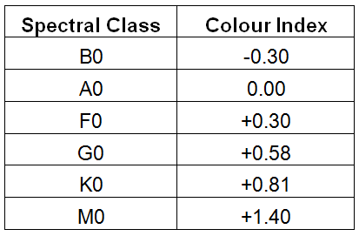Therefore, this means a star with a more negative B-V colour index will be hotter (i.e. have a warmer surface temperature), since hotter stars emit more energy at blue wavelengths than at red whilst the emission of cooler stars strays towards the red wavelengths.
* The link between colour index (here “B-V Colour Index”) and spectral class is shown in the table to the right:
* Note: The B – V colour index is simply the most common two-colour value. Other two-colour values can be obtained by using two different filters to determine two ‘colour magnitudes’ which then results in a colour index (e.g. U-B, V-R, R-I).
* Note: Remember that a star’s "shade" of colour is an indistinct, relative term whereas any colour index is a directly measurable, absolute value.
* Here is another table (below) which shows the correlation of colour index, colour, temperature and spectral class:

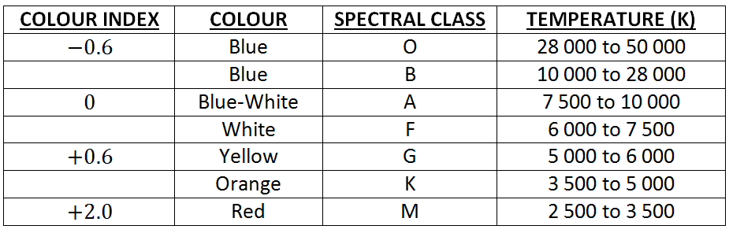

* *Example Q* 🡺
  + **Question** 🡪 Achernar has a B-V colour index of –0.16 whereas Aldebaran has an index of +1.54. Which star is hotter and why? Which star will appear redder and why?
  + **Solution** 🡪 Acharnar has a lower colour index and, thus, will be hotter. Aldebaran has a higher colour index and, thus, will appear more red in colour.

The Significance of the Colour Index

* The concept of ‘colour index’ is extremely useful to astronomers, as it enables a determination of a star’s ‘colour’ (and, hence, its spectral class and temperature) without the use of spectroscopy. This means that spectroscopy is not required for the determination of the star’s spectral class – one of the steps involved in the process of spectroscopic parallax.
* Also, colour index readings can be collected quickly by automatic equipment (e.g. aboard a satellite) and the data can be processed by a computer. Thus, colour indexation is ideal for automatic star surveys of thousands of stars, with modern systems using up to a dozen different filters for increased precision.

***Describe the advantages of photoelectric technologies over photographic methods for photometry***

* For the purposes of photometry, traditional photographic methods using light-sensitive film emulsion (based on the reaction of silver salts) have been used
* Advantages of CCDs:
  + Have a more uniform response across the visible spectrum than photographic film does
  + Are sensitive to a wider range of wavelengths (especially infrared) than photographic film
  + Provide a greater resolution
  + Allows information to be collected much more quickly and to be transmitted digitally
  + Enables data to be processed more easily and quickly

***Solve problems and analyse information using: $M=m-5\log{(\frac{d}{10})}$ and $\frac{I_{A}}{I_{B}}={100}^{(m_{B}-m_{A})/5}$***

***to calculate the absolute or apparent magnitude of stars using data and a reference star***

* The formula $M=m-5\log{(\frac{d}{10})}$ and its terms were introduced in a previous dot point.
* *Example Q* 🡺
  + **Question** 🡪 A newly discovered star is 40 000 parsecs away from Earth and has an apparent magnitude of +21.0, according to astronomers. What would be your estimate of the star’s absolute magnitude, to 2 decimal places?
  + **Solution** 🡪
* *Example Q* 🡺
  + **Question** 🡪 A star has an apparent magnitude of +1.25 and an absolute magnitude of –3.72. How far is this particular star from Earth?
  + **Solution** 🡪
* A problem with the magnitude scale is that it is not linear, and this is due to the human eye detecting light in a logarithmic fashion. Thus, N.R. Pogson discovered that stars of ‘magnitude 1’ were 100 times brighter than stars of ‘magnitude 6’. Therefore, Pogson stated that each successively higher magnitude was $\sqrt[5]{100}$ (approx. = 2.512) times brighter than the preceding magnitude.
* Therefore, this led to a new formula $\frac{I_{A}}{I_{B}}={100}^{(m_{B}-m_{A})/5}$, where:
  + $\frac{I_{A}}{I_{B}}$ is the brightness ratio of star A relative to star B
  + mA is the apparent magnitude of star A
  + mB is the apparent magnitude of star B
* *Example Q* 🡺
  + **Question** 🡪If the Sun and the full moon have apparent magnitudes of –26.71 and –12.74 respectively, then how many times brighter is the Sun compared to a full Moon?
  + **Solution** 🡪
* *Example Q* 🡺
  + **Question** 🡪 Stars must have an apparent magnitude equal to or greater than +6.0 to be seen by the naked eye, whereas the Hubble Space Telescope can view stars as faint as +30.0. How much fainter are the faintest objects visible to the Hubble Space Telescope relative to the dimmest stars visible to the unaided eye?
  + **Solution** 🡪

***Perform an investigation to demonstrate the use of filters for photometric measurements***

* Here is the method:

1. Set up an incandescent light source (which produces a continuous spectrum), such as a light globe or a lamp in a ray box.
2. Now, obtain something that can be used as a filter. Ray box kits have coloured filters suitable for use in this investigation, and if not, coloured cellophane will suffice as a filter.
3. Also, set up either a light meter or a light detector attached to a data logger to record the intensity of the light through various coloured filters as well as without the filter. Make sure this measuring device is kept at a constant distance from the light source.

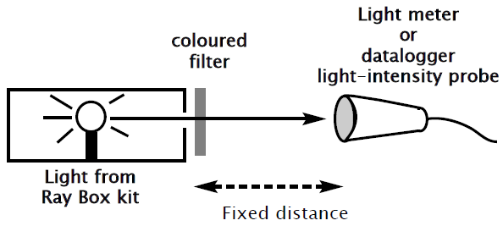

1. As a result, take a measurement of the brightness of the light source through a yellow (V) filter and then through a blue (B) filter.
2. Subtract the measurement V from B and this B–V value is a standard quantitative representation of the colour of the star.
3. If possible, change the temperature of the light source (e.g. by changing the supplied voltage) and take another set of readings.
4. Keep in mind that the brightness of the light through each filter is represented by the intensity that is measured.

***Identify data sources, gather, process and present information to assess the impact of improvements in measurement technologies on our understanding of celestial objects***

* Over time, there has been considerable improvement in measurement technologies and this has enhanced our understanding of celestial objects. In fact, our modern understanding of celestial objects is pretty much due to advances in the technology of detecting, measuring and analysing stellar radiation.
* For example, early measurements of star brightness by the Ancient Greeks were solely judged using the naked eye. Photographic techniques have now been developed and applied, with a subsequent increase in accuracy. Most recently, electronic devices (e.g. photomultiplier tubes, charge coupled devices) have been employed to measure star brightness with further improvements in sensitivity and faster response times. It also enables data to be analysed in a digital format by computers, with rapid analysis and easier storage.
* Another example is the development of the radio telescope in the 1950s after the accidental discovery that the cosmos is filled with radio waves and microwaves. This introduction then led to the discovery of countless celestial objects such as pulsars and quasars. This then contributed to an enhancement in our understanding of how stars evolve and die.
* Also, the introduction of technologies such as interferometry, active optics and adaptive optics have improved the resolution & sensitivity of telescopes and minimised the effects of wavefront distortion – improving the quality of measurements yet again. In fact, the introduction of adaptive and active optics led to the discovery that the Andromeda galaxy was actually 3 times bigger than previously thought. Furthermore, the use of interferometry has been critical to measuring the diameters of nearby stars, such as the red giant Betelgeuse.
* Telescope-carrying satellites have been critical to enhancing our understanding of celestial objects. Located above the Earth’s atmosphere, these telescopes are able to collect radiation 24 hours a day, without the problems of air pollution, light pollution, atmospheric turbulence and weather conditions which affect ground-based telescopes. Also, unlike Earth-based telescopes, space-based telescopes are able to detect and analyse X-rays (emitted by black holes and the Sun’s corona), infrared radiation (enabling us to observe celestial objects hidden by clouds of dust/gas and protostars as they form) and the full range of microwaves (which provided strong evidence for the Big Bang Theory). Space-based telescopes are also able to accurately observe and analyse radiation from stars up to 1000 parsecs away, in contrast to the maximum of 30 parsecs for Earth-based telescopes.